1. DOM-based open redirection 1
2. DOM-based cookie manipulation 1
3. DOM XSS using web messages 1
4. DOM XSS using web messages and a JavaScript URL 2
5. DOM XSS using web messages and JSON.parse 2

DOM-based open redirection

DOM-based cookie manipulation
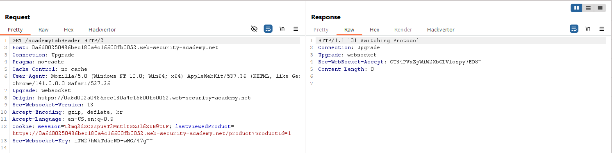

DOM XSS using web messages
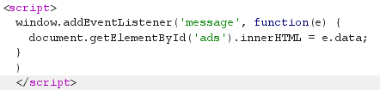

DOM XSS using web messages and a JavaScript URL
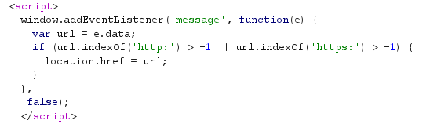

DOM XSS using web messages and JSON.parse
